**Team Orange Project Proposal**

Anthony Sands

Chenxu Liu

Christopher Kern

Christopher Paez

Kasius Graff McCall

IST 331 – Foundations of Human-Centered Design

Professor Wenk

6 February 2022

**Description of the proposed interface redesign:**

When it comes down to the Wowser the Lazy Dog Website’s current user interface, there are quite a few things that immediately come to my mind regarding how to fix the aesthetics, let alone functionality. One important thing to note is that this website is all one very single page, with no menus to get into other sections of information. So, here’s a quick breakdown of the problems with this site from top to bottom.

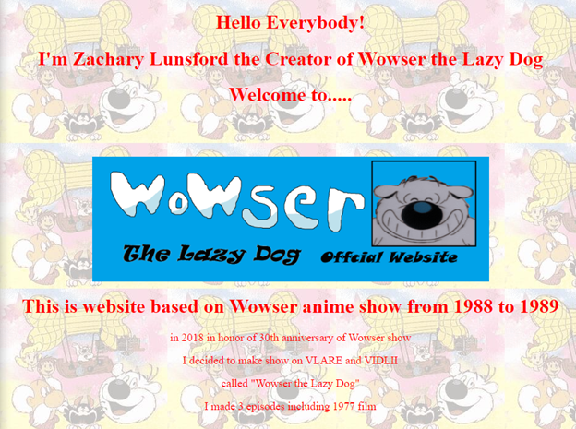

Here is the top of the page, which overall is just jarring when it comes down to the color themes. Red text with a high contrast background, and an oddly placed giant blue rectangle splotch in the middle is just too cluttered.

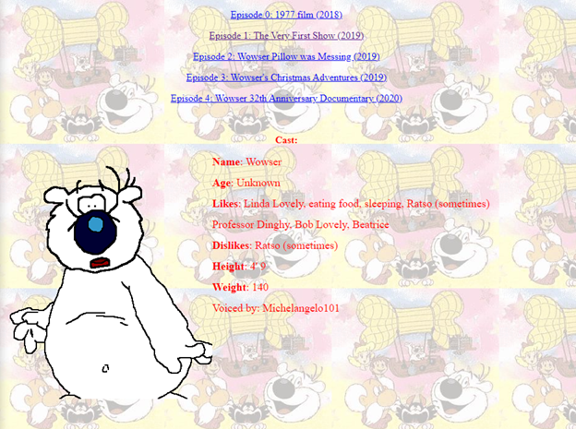

What comes after that first section of the page is also quite a mess. There are five hyperlinks to videos, of which do not have an embedded video player for you to watch right there, forcing you directly into a new page with the chosen video. This could be done so much better, but at least all five links are within one of the rectangles established by the background, unlike what follows directly after with the beginning of the cast section starting at the bottom of the same rectangle as the hyperlinks, which adds to the odd clutter and disorganization of this site. The trend of things not fitting within rectangles continues as the site goes on, as seen in the following screenshots

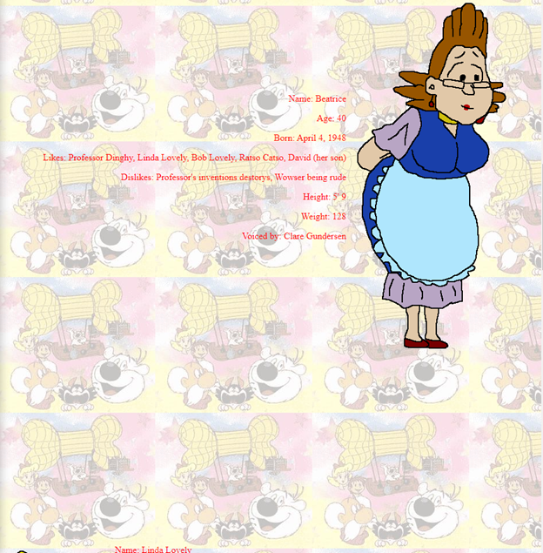

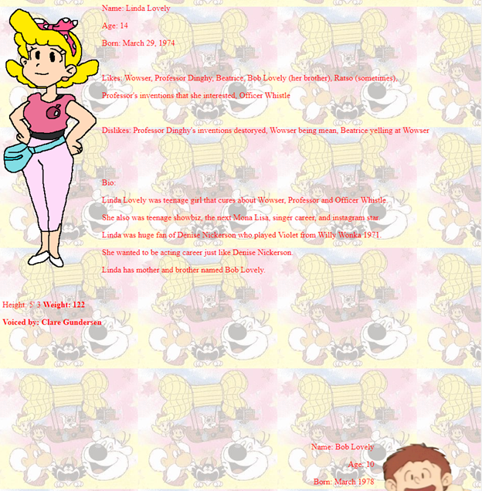

There’s still another quarter of the website that is exactly like this, and that’s just about all there is. Now that this is established, it’s time to talk about what an ideal redesign here would entail. The first thing I’d start with, as briefly stated earlier, would be a massive facelift for the aesthetic and theme choice, creating something that all flows within the same color scheme and in a far cleaner matter. That being the very first and most simple thing to get out of the way with, next I would divide everything into tabs. Starting with the home page that contains the description of the show, there would be a navigational menu bar on the top or side of the page that will lead you to a section for the videos that would be accompanied with their own descriptions tailored for each one, one tab that expands on the history of the show for those looking to do some extended reading, and then one that contains all the cast information.

The home page would have the description of course, alongside a picture like that of the big blue rectangle image at the top of the page but done in a way that is far more pleasing to the eyes. For the videos page, I would have each video embedded onto the page that has a brief description for each either to the side or directly below. The history section would show extra images alongside an extended description of the show, as well as any potential videos that could be thrown into the mix as well. Lastly, the cast page would need to be the most touched up in terms of the design stage, as they should be linked into one page like done here, rather a central hub showing everyone in the cast by name, and then that tab in the menu can have additionally broken-down sub-tabs for each of the characters.

These sub-tabs of course would be completely character specific, showing their bios and info like before, with several images of the characters, if possible, alongside extra information on the voice actors as well. All in all, there is so much to play with here regarding creating a far more visually appealing, user friendly, and overall cleaner user interface, and I’m really excited to see what our result looks like. I’m personally hoping to bring a lot of the nuance that modern sites have these days to this interface, while keeping the soul of the show and its history intact, rather than detracting from the charm of its older art style.

**Purpose of the system:**

The website, Wowser the Lazy dog, was created by Zachary Lunsford in 2018 with the purpose of honoring the 30th anniversary of the animated show that ran from 1988 to 1989. It is based on the Franco-Belgian comic, Cubitus, and has a cult following even though it was only on the air for close to one year. The website is clearly a relic from the nineties and our purpose with this project is to create a brand-new website and look for 2022. The website is very basic and even features two dinosaurs at the bottom of the website in the footer as seen in figure 1.



The show has a niche following and our goal is to give the community a service by revamping their website and bringing it into the new millennium.

**Expected Users:**

The expected users are definitely fans of the Wowser anime show, this website is more like a commemorative website. There are many anime characters on this website, I believe they are the Classic role in the fans’ memory. On one hand, old fans can come to this website to reminisce. On the other hand, it’s like a museum that was provided to visit to prove these characters existed.

**Discussion:**

The current website interface looks very outdated, unformatted, unappealing, has poor visibility of system status, and lacks consistency and standards. Our goal is to redesign the website so that it looks more modern, aesthetic, and up to date. Furthermore, the interface will be easier to navigate and will include error prevention and provide help and documentation (Help/FAQ page).

Current website: <http://www.geocities.ws/wowserthelazydog/>

**Images:**

